|  |
| --- |
| EPAM Systems, RD Dep. |
| MTN.BI.07 Partitioning |

|  |  |  |  |  |  |
| --- | --- | --- | --- | --- | --- |
| REVISION HISTORY | | | | | |
| Ver. | Description of Change | Author | Date | Approved | |
| Name | Effective Date |
| 1.0 | Initial status | [Kiryl Bucha](mailto:Kiryl_Bucha@epam.com) | 12-JAN-2012 |  |  |
| 2.0 | Updated in accordance with renewed content | [Elias Nema](mailto:Elias_Nema@epam.com) | 20-JAN-2014 |  |  |

Contents

1. Hands-On Task 3

2. Data Modeling Task 3

3. Analytical task 3

3.1. Partitioning 3

3.2. Business 3

4. Results 3

# Hands-On Task

Create any table with some kind of partitioning to show next concepts:

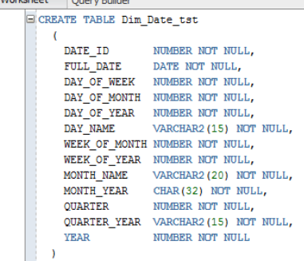

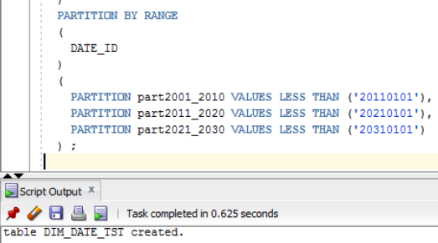

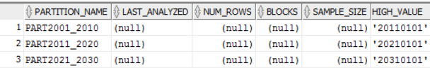

* Adding Partition.

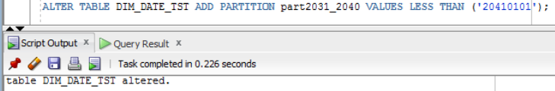

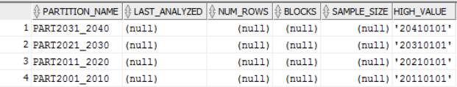

* Coalescing Partition.

Coalescing partitions is a way of reducing the number of partitions in a hash-partitioned table. When a hash partition is coalesced, its contents are redistributed into one or more remaining partitions determined by the hash function. The specific partition that is coalesced is selected by the database, and is dropped after its contents have been redistributed.



* Dropping Partition.

This is the fastest method to drop huge amount of data. By partitioning the data, dropping the whole partition takes mere seconds, as opposed to hours with traditional "delete" techniques.

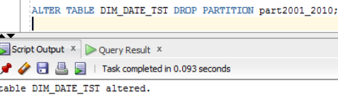

* Merging Partition.

In the MERGE PARTITION we should specify both partitions we merge and into which partition we merge.

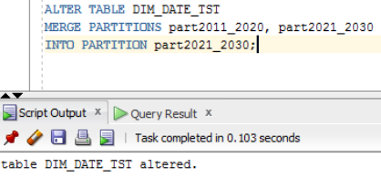

* Moving Partition.

!!!ONLY FOR HASH TABLES

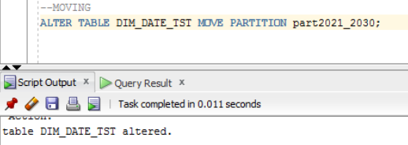

* Splitting Partition.

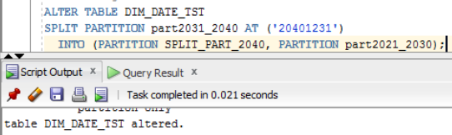

* Truncating Partition.

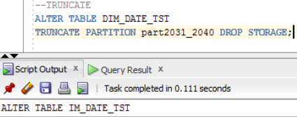

# Analytical task

## Partitioning

Add chapter on describing Fact table partitioning strategy, which fields will it be based on and why (use composite partitioning).

## Business

Create a report layout of the task you are trying to solve with your DWH (e.g. 'I want to analyze my sales on month and customers' region location and product type'). It could be done in Excel (just some headers, colors, dummy numbers, and little description) or any other tool of your preference. This would help to understand what task we are trying to solve.

# Results

Result of this lab work should be:

* Screenshots and description of partitioning maintenance operations.
* Chapter in document about advantages of partitioning the fact table in described way.
* Chapter in a document describing needed reports with possible layouts.